
Register Number

SRM INSTITUTE OF SCIENCE AND TECHNOLOGY
Set - A
SRM Nagar, Kattankulathur – 603203, Chengalpattu District, Tamil Nadu
College of Engineering and Technology
School of Computing
Department of Data Science and Business Systems
Academic Year: 2023-24 (Odd)

Test | : CLA-T3 | Date | : 02-11-2023
Course Code & Title | : 18CSE487T – Data warehousing and Its  Applications | Duration | : 90 Minutes
Year & Sem | : III&IV Year /V& VII Sem | Max Marks | : 50

Course Articulation Matrix:
S.No. | Course Outcome | PO1 | PO2 | PO3 | PO4 | PO5 | PO6 | PO7 | PO8 | PO9 | PO10 | PO11 | PO12 | PO13 | PO14 | PO15
1 | CO1 | 3 | - | - | - | - | - | - | - | - | - | - | - | - | - | -
2 | CO2 | 3 | - | - | - | - | - | - | - | - | - | - | - | - | - | -
3 | CO3 | 3 | - | - | - | - | - | - | - | - | - | - | - | - | - | -
4 | CO4 | 3 | - | - | - | - | - | - | - | - | - | - | - | - | - | -
5 | CO5 | 3 | - | - | 3 | - | - | - | - | - | - | - | - | - | - | -
6 | CO6 | 3 | - | - | - | - | - | - | - | - | - | - | - | - | - | -

Part - A
(5 x 1 = 5 Marks)
Instructions: Answer all
Q. No | Question | Marks | BL | CO | PO | PI Code
1 | Data mining is?  a) time-variant non-volatile collection of data  b) The actual discovery phase of a knowledge  c) The stage of selecting the right data  d) Evaluate the result | 1 | L1 | 4 | 1 | 1.6.1
2 | A collection of one or more items is called as _____  a)Itemset  b)Support  c)Confidence  d)Support Count | 1 | L2 | 4 | 1 | 1.6.1
3 | The data (better, good, excellent) are ___________  a) Nominal  b) Ordinal  c) Continuous  d) Discrete | 1 | L2 | 4 | 1 | 1.6.1
4 | Which website has details about data marts on village facilities, rainfall, agriculture census, commodity price etc. _______  a) GISTNIC  b) RAINMAP  c) AGRIDET  d) VILLAGE | 1 | L2 | 5 | 1 | 1.6.1
5 | What is the term used for the value that a decision tree predicts for an instance?  a) Split  b) Node  c) Leaf  d) Branch | 1 | L1 | 4 | 1 | 1.6.1
Part – B
( 3 x 5 = 15 Marks)
Answer ANY THREE Questions
6 | Explain about different types of decision trees | 5 | L2 | 4 | 1 | 1.6.1
7 | Write about Bayes theorem. | 5 | L1 | 4 | 1 | 1.6.4
8 | What are AGNES and DIANA clustering? | 5 | L1 | 4 | 1 | 1.6.4
9 | Write about multilevel association rules with suitable example. | 5 | L1 | 5 | 1 | 1.6.1
Part – C
( 3 x 10 = 30 Marks)
Answer ANY THREE Questions
10 | Write about Frequent pattern mining with a suitable algorithm. | 10 | L3 | 4 | 1 | 1.6.4
(or)
11 | Explain in detail clustering with k-means and hierarchical clustering. | 10 | L3 | 4 | 1 | 1.6.4
12 | Explain in detail data warehousing in Hewlett-Packard. | 10 | L1 | 6 | 4 | 1.6.4
(or)
13 | Write about data warehousing for the Ministry of Commerce. | 10 | L1 | 5 | 1 | 1.6.4
14 | Explain in detail the decision tree classification with suitable examples and implementation. | 10 | L3 | 4 | 1 | 1.6.1
(or)
15 | Write about Naïve Bayes classification with implementation | 10 | L3 | 4 | 1 | 1.6.4

Course Outcome (CO) and Bloom’s level (BL) Coverage in Questions

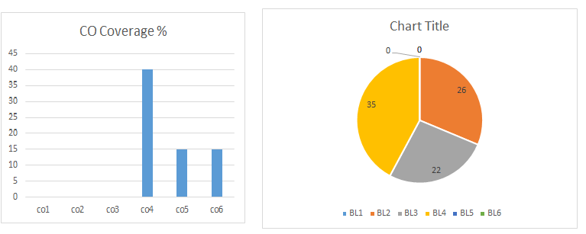

Approved by the Audit Professor/Course Coordinator

